# **FINAL REPORT**

Contents

**FINAL REPORT** 1

**1.Summary of problem statement, data and findings** 3

**Data** 3

**Findings** 3

**2.Overview of the final process.** 4

**Methodology** 4

**Exploratory Data Analysis** 4

**Salient Features of the data** 4

**Data Pre-processing** 4

**Algorithms used** 5

**3.Step-by-step walk through of the solution** 10

**A. Exploratory Data Analysis** 10

**B. Pre-processing the data** 17

**Identifying algorithms** 19

**Model Training** 19

**Tune the model for higher accuracy. The parameters used were - accuracy, mAP, and inference time.** 20

**Integrating the model with a GUI** 20

**4.Model evaluation** 20

**SSD Mobile Net** 21

**Faster RCNN** 22

**YOLOV5** 24

**5.Comparison to benchmark** 26

**6.Visualizations** 26

**F1 Curve** 27

**PR Curve** 27

**P Curve** 28

**R Curve** 28

**Confusion Matrix** 29

**Example predictions** 30

**7.Implications** 35

**Used Car Portal** 36

**Car Garage** 36

**8.Limitations** 36

**9.Closing Reflections** 37

## **1.Summary of problem statement, data and findings**

The objective of this project is to build a car classification and detection model with GUI. When an image is input through the GUI, the model would draw a bounding box and provide information about the make and the model of the car. The dataset used to train the model is Stanford Car Dataset. It contains multiple attributes about the car that can be used to detect the class of the car in the image.

This application can be used to identify cars from images that has application across different fields like -

1. Crime investigation - When they have to identify a car from a video feed, they could use this model. That way they can get the make and model of the car quickly.
2. Used car portals - Use case - When users upload the picture of their car to sell, the UI Model could complete the other fields automatically for them. Also, this can be used to provide recommendations for similar cars for the users.
3. Journalism - Can be used to identify and describe a photo. Like in the caption, it could be detailed, user passing before a car.
4. Car Counting - Could be used by the manufacturers for market study, counting cars of a particular type that are running in an area. This could be used by the authorities as well. Since they might be interested in understanding the age of the cars that is currently plying the road.
5. Car Services - Could be used to provide after sales service.
6. Car Garage - Car Garage door manufactures could implement this model, to understand the type of the cars and track it centrally.

### **Data**

The data used is the Stanford Car Data. The Cars dataset contains 16,185 images of 196 classes of cars. The data is split into 8,144 training images and 8,041 testing images. The testing and the training images have been split roughly in a 50-50 split. Classes are typically at the level of Make, Model, Year, e.g. 2012 Tesla Model S or 2012 BMW M3 coupe.

### **Findings**

#### **Generic Findings:**

1. Accuracy of 92% has been reached with YOLO.
2. The model can be exported to integrate with a flask front end, and can be deployed in servers.

#### **Specific Findings:**

1. PCA improves the speed of the training. The accuracy is not reduced.
2. Data Augmentation improves the accuracy of the model.
3. YOLOv5 provides a better accuracy and faster interpretation time.

## **2.Overview of the final process.**

The problem is an object detection problem. A model is trained to detect within the 196 classes it is trained on. When an image is provided with the car object, the model would detect the object and classify it within the 196 classes it is trained on. It would also draw a bounding box around the object.

### **Methodology**

The methodology we followed is to go through the following steps:

1. Exploratory Data Analysis
2. Pre-processing the data
3. Identifying algorithms that can be tested based on the data available and the solution space - object detection.
4. Designing experiments to tune the model for higher accuracy. The parameters used were - accuracy, mAP, and inference time.
5. Integrating the model with a GUI

### **Exploratory Data Analysis**

The data is analyzed statistically to ascertain the following:

* Identify the number of classes present.
* The amount of data present for each of the class provided.
* Anomaly in the data.
* The different sizes of the images present.

### **Salient Features of the data**

* 196 classes
* 16,185 images
* 8,144 training images
* 8,041 testing images

### **Data Pre-processing**

Since this is an image data, the techniques applicable for image processing were taken up. The major pre-processing steps were:

1. Augmenting data - Horizontal flip, blurring the images, adding noise to the image, and rotation of the images to a slight degree.
2. PCA - We compressed the image using PCA. We took the n=50 since that provided the best trade-off.
3. Images were moved into the folder structure required for YOLO.
4. YOLO algorithm required that labels were generated as a text file.
5. YOLO also required the bounding box co-ordinate to be normalized starting x, y offset, and normalized height and width offset.
6. Dividing training images into train and validation split. We used 20% of training data for validation.

### **Algorithms used**

Since this is an object detection problem following algorithms were used:

#### **1) CNN (Control Algorithm) -**

CNN is used a custom CNN object detection model. This is a vanilla model. In this model, we have added two output sub networks from VGG output - one classification network for predicting the class and one regression network for predicting bounding box. This model did not provide a good accuracy for image classification hence we have not pursued it further. 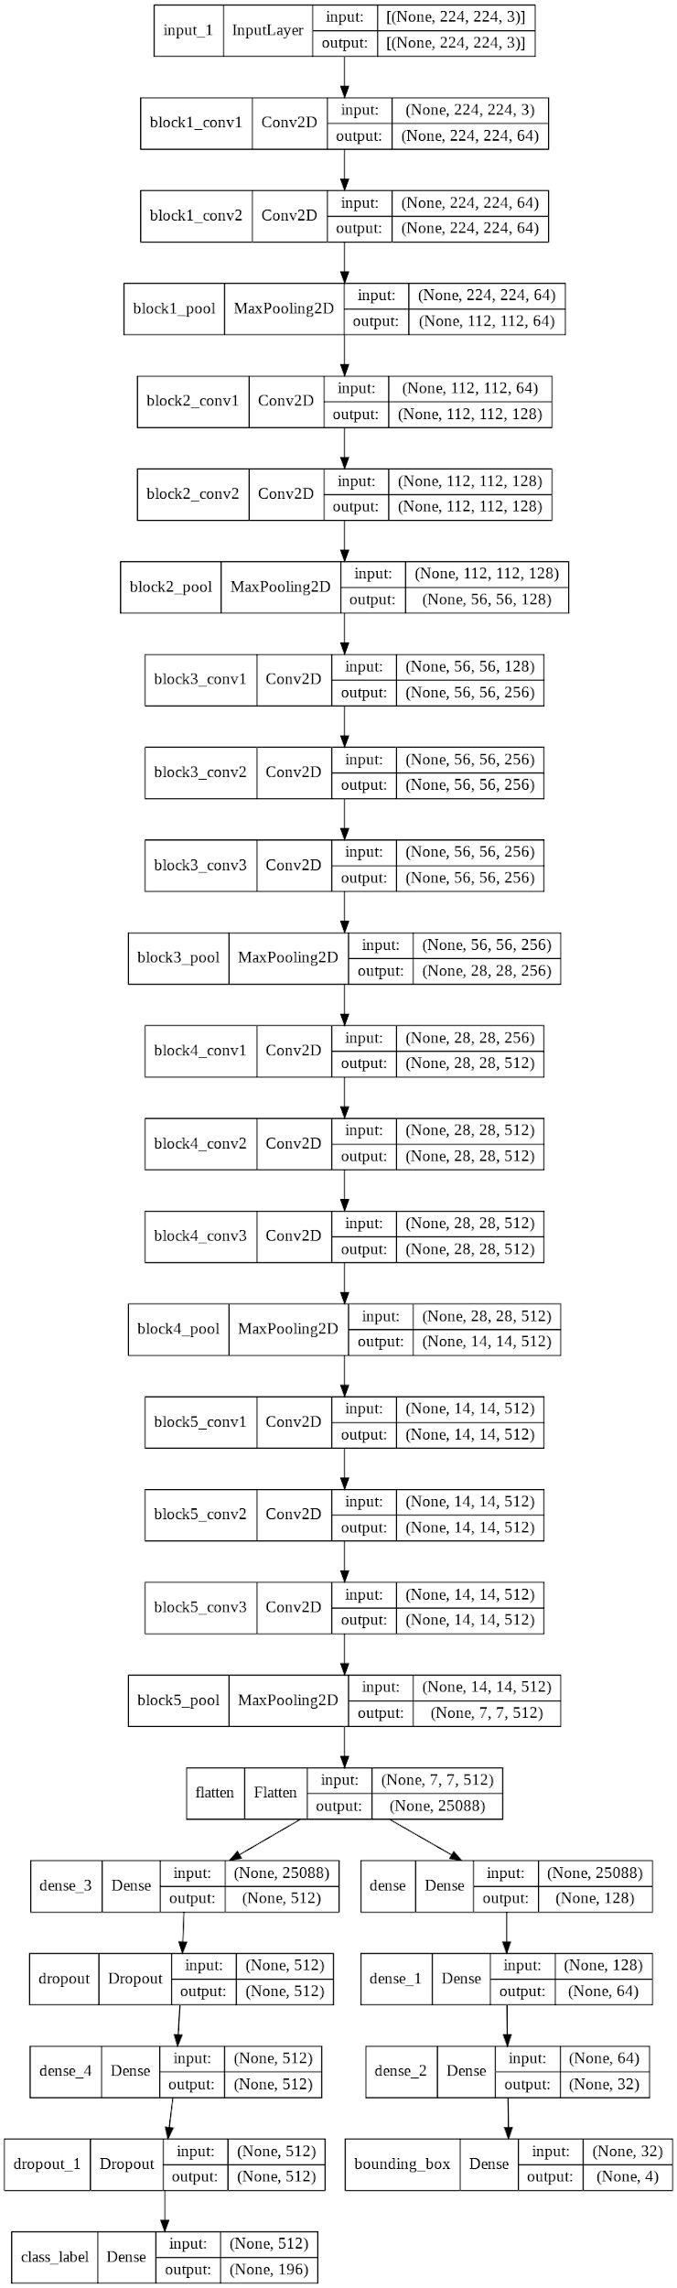

#### **2) SSD -**

SSD (Single Shot MultiBox Detector) is a popular algorithm in object detection. It’s generally faster than Faster RCNN. The SSD architecture is a single convolution network that learns to predict bounding box locations and classify these locations in one pass. Hence, SSD can be trained end-to-end. The SSD network consists of base architecture (MobileNet in this case) followed by several convolution layers: 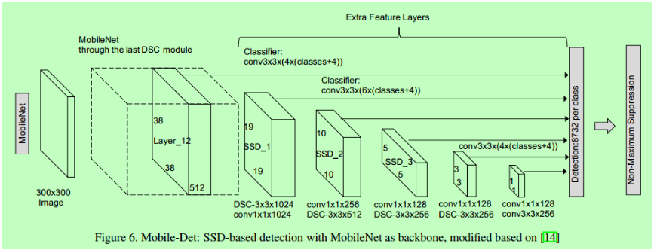

#### **3) Faster RCNN (Two step approach) -**

Following are the major reasons for choosing Faster R-CNN over RCNN:

1. R-CNN would need to classify 2000 region proposals.
2. R-CNN takes around a minute for each test image, hence cannot be used for real time.
3. Learning even at the RoI pooling layer. 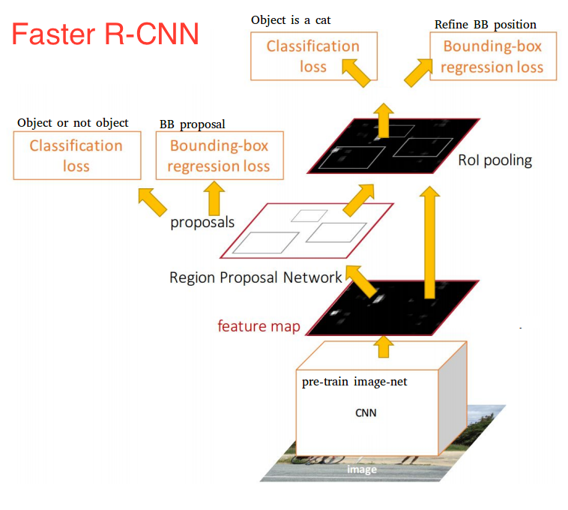

#### **4) YOLO V5 (One shot Detection) -**

YOLO is a state of art algorithm for object detection. This is the fastest and accurate object detection algorithm. This is because it is one-shot learning algorithm. It skips the region proposals layer.

For this project we need an algorithm to work in real time, rather than batch processing, hence speed is significant.

The biggest drawback of YOLO is that it cannot detect small and very small images. However, in the dataset we have cars which occupy more than one grid of YOLO. Hence, this drawback is not significant with YOLO.

We tested multiple algorithms to obtain the best model that would satisfy the parameters that we had identified. We have worked with TensorFlow object detection API for RCNN and SSD. We have pyTorch based API for YOLO.

## **3.Step-by-step walk through of the solution**

### **A. Exploratory Data Analysis**

#### **Number of classes in Train and Test Dataset**

In the train dataset, we have 8144 pictures of cars and in the test dataset, we have 8041 pictures of cars.

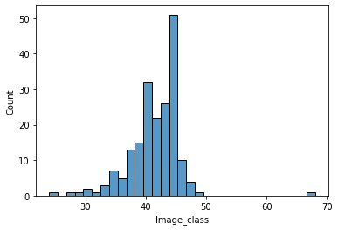 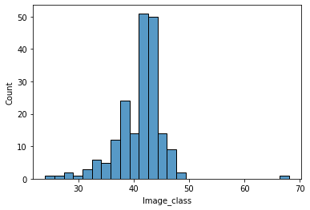

#### **Eyeballing the cars**

##### **Train Dataset of images with the bounding boxes**

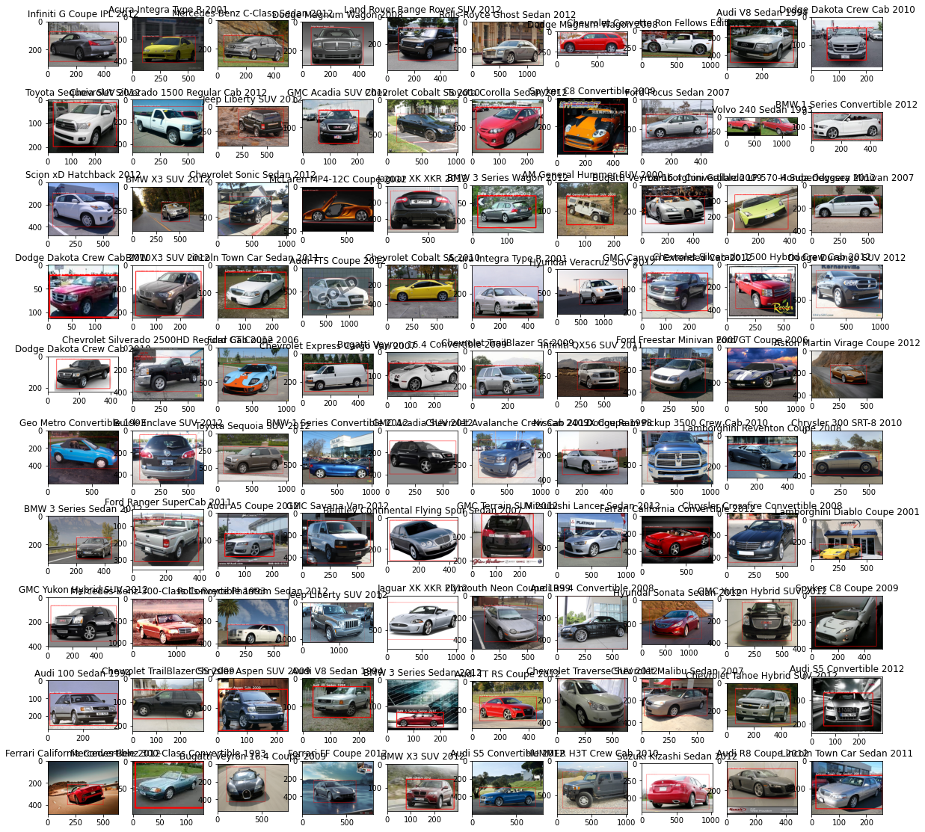

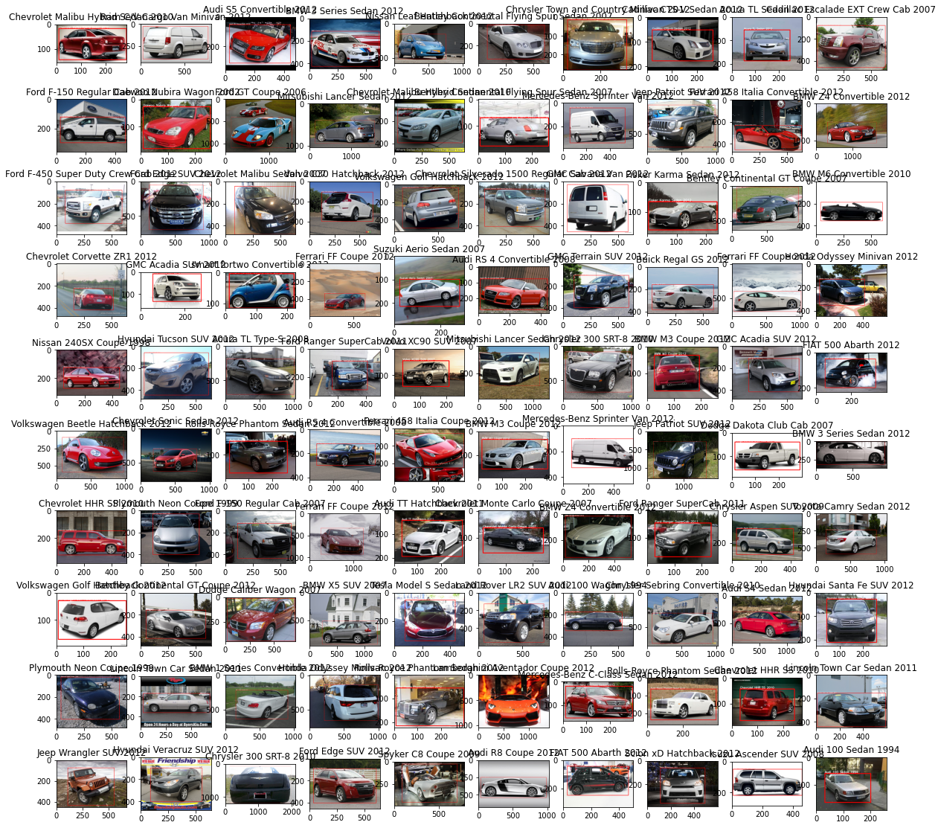

#### **Removal of outliers and anomaly**

We looked into the aspect ratio of the images and their bounding boxes. The images and bounding boxes with extreme aspect ratios could be outliers or an anomaly. Following are the histogram for Aspect Ratio(AR)

##### **Aspect ratio of Images and bounding boxes**

 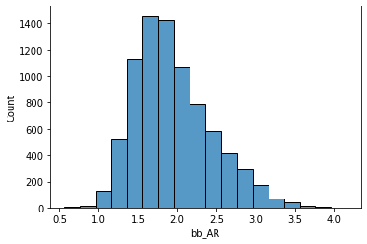

Based on the above diagrams we could infer that there there are few outliers in terms of the aspect ratio of bounding boxes. This could be because of the shape of cars. The sedans and sports cars would have a very different aspect ratio to cars like Minivans, and others. It also could be that the angle of the photographs would cover the entire picture. So, the outlier aspect ratios are looked into.

##### **Images with high aspect ratio**

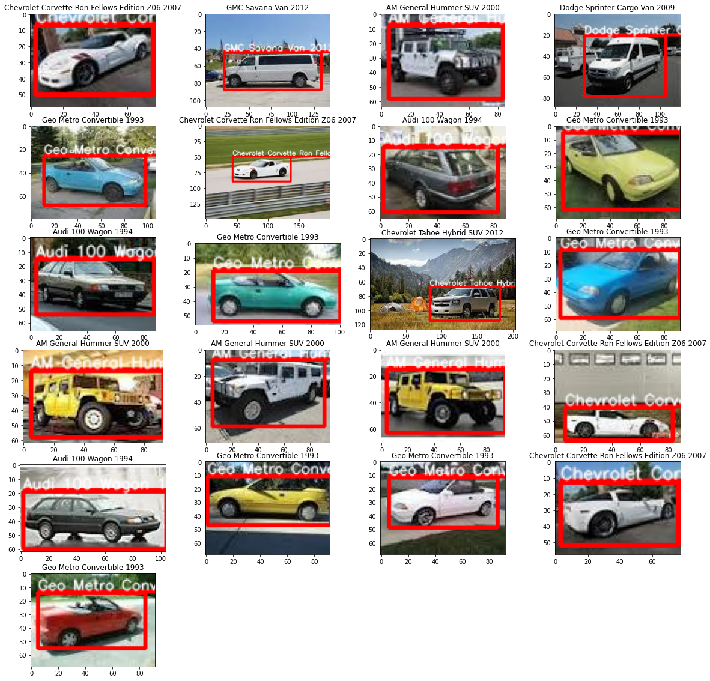

##### **Images with low aspect ratio**

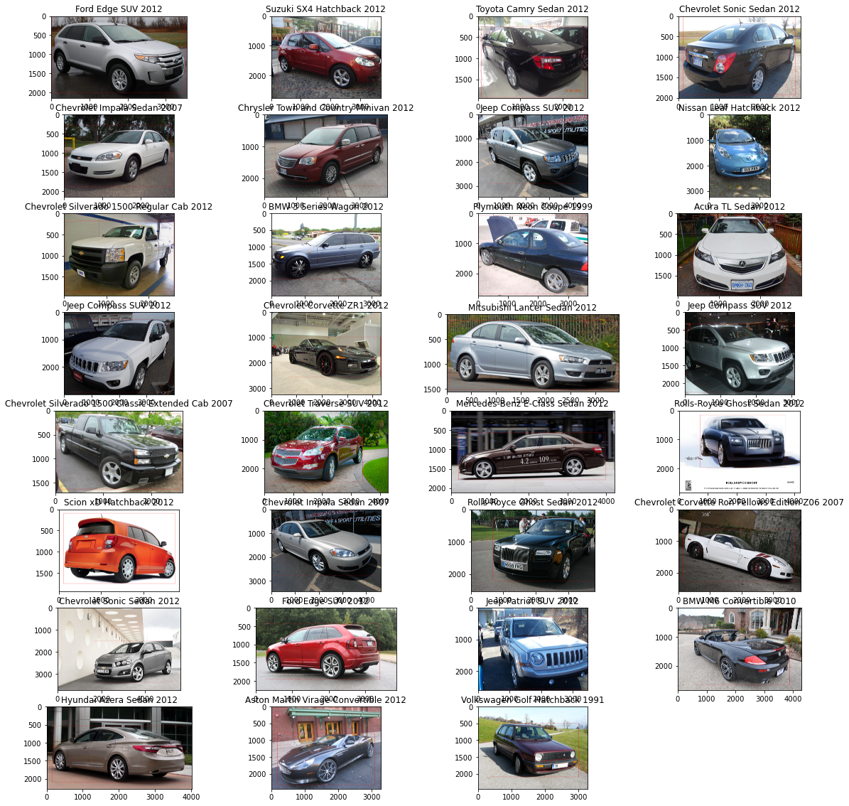

From the above we could see that though these are outliers, they are not wrongly classified. Just that the images are different and with different angles. We have chosen to include these images, since there is a possibility that we could detect similar objects during testing.

##### **Scatter plot for h and w**

##### Scatter plot for h and w would provide us a way to see if there are outliers.

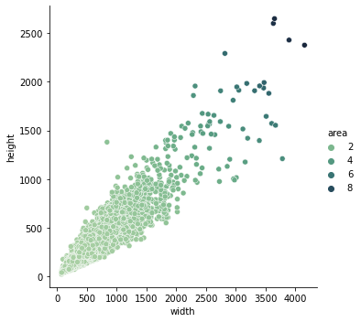

##### **Histogram of area of the bounding box**

Histogram for area.

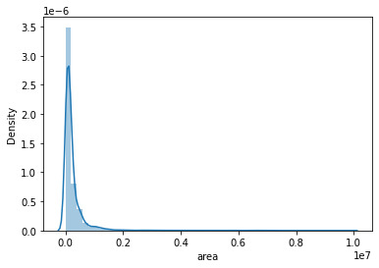

#### **Inference from EDA**

Following are the inference from EDA:

1. We have class imbalance, need to do data augmentation of minority classes.
2. We have both black and white and colored images.
3. We have images with different aspect ratios. Most of the images lie 1.3 and 2.0. when we resize the image for model training, we need to take care of maintaining the high aspect ratio.
4. The aspect ratios of the bounding boxes fall in the range of 1.0 to 3.5. The reason for the variance of this bounding box could be because of the nature of the cars. For ex. Sedans and sports cars would have a higher width to height ratio compared to hatchbacks.

### **B. Pre-processing the data**

#### **Folder Structure**

The folder structure that is provided in the input needs to be converted to the folder structures required by the TensorFlow API, and YOLOV5 algorithm. This is very important step to ensure the algorithms function as prescribed.

#### **PCA**

PCA decomposition was used to compress the image during training. Following is an original image that is used for PCA decomposition

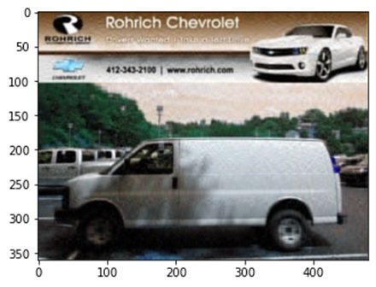

The image is further split into each of its channel. The image channels are shown below:

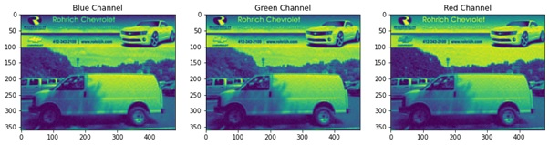

For each of the channel the PCA for n=50 is performed. The eigen values and the variance explained is plotted for each of the channel:

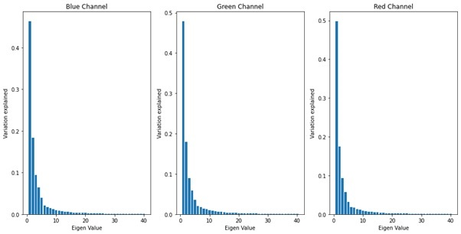

This might be different for each image. However, with n=50 most of the variance is explained. This would be true for images similar in nature. Hence n=50 is used since it provides a margin of safety.

The following image shows the before and after of the above image compressed with PCA. As can be seen there is not much of a visible difference.

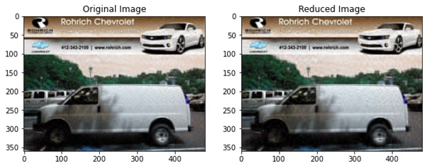

The advantage of using PCA is that it reduces the training time. With YOLOV5, PCA provided a 10x improvement in processing time. Without PCA 20 runs took as much time as 200 runs with PCA.

#### **Dividing into train and validate**

The training image set is divided into train and validate with a ratio of 80:20. This validation set is used during the training. YOLOV5 requires that al the image to be considered for validation be moved to a specific validation folder. The images are moved. The path for the images are then configured.

### **Identifying algorithms**

As explained earlier in detail, the algorithms were identified based on the problem space (object detection).

### **Model Training**

Initial model training was done for all the algorithms identified. Based on the initial model training, the algorithms were selected for final tuning. In the first pass the SSD and the CNN model was way below the benchmark of 90% accuracy chosen.

Though SSD and CNN made use of the augmented dataset still their improved performance was under the accuracy benchmark. Hence the two algorithms were dropped.

Both YOLOV5 and RCNN algorithm were chosen for further optimizations. YOLOV5 had shown great progress in the initial stages itself. Also, YOLOV5 algorithm is computationally faster than RCNN and is also giving good accuracy. So, we have chosen YOLOV5 as our final model for the given problem statement.

### **Tune the model for higher accuracy. The parameters used were - accuracy, mAP, and inference time.**

YOLOV5 was initially trained with 160 sized image, and epoch of less than 100. However, the model did not perform well, and was below the benchmark.

Hence the size of the image was increased to 224. The epoch was also increased to 300. This provided an accuracy greater than the benchmark.

Hyper parameter tuning of the YOLOV5 was planned, however it was not required because of the following:

1. The baseline performance was reached with the smallest pre-trained model (YOLOV5s)
2. Since the dataset was huge, it took huge amount of computational power to perform the experiments. The cloud GPU was exhausted. Hence better hardware must be used used for hyper parameter training.

### **Integrating the model with a GUI**

Flask based front end was chosen for the GUI. The GUI was purposefully kept simple to demonstrate the model. The flask application contained the following:

1. A simple form that would input an image.
2. The image input is processed using the backend server.
3. Then the image is input into the model.
4. The output is displayed as the result.

## **4.Model evaluation**

We have decided on the final model after evaluating the following:

1. Loss
2. mAP@.5
3. mAP@.5:.95

Following table illustrates the loss from multiple different algorithms:

|  |  |  |  |
| --- | --- | --- | --- |
|  | **SSD** | **Faster RCNN** | **YOLOV5** |
| Total Loss | 0.32 | .9 | .03 |
| [mAP@.5](mailto:mAP@.5) | 0.65 | NA | 0.871 |
| mAP@.5:.95 | 0.65 | NA | 0.798 |

Based on the preliminary analysis YOLOV5 is better. Hence, it is taken up for further training and tuning.

### **SSD Mobile Net**

Step 25100 per-step time 0.647s INFO:tensorflow:

{'Loss/classification_loss': 0.21411954,

'Loss/localization_loss': 0.020920731,

'Loss/regularization_loss': 0.09270904,

'Loss/total_loss': 0.3277493,

'learning_rate': 0.041025713}

#### **SSD Loss Graph**

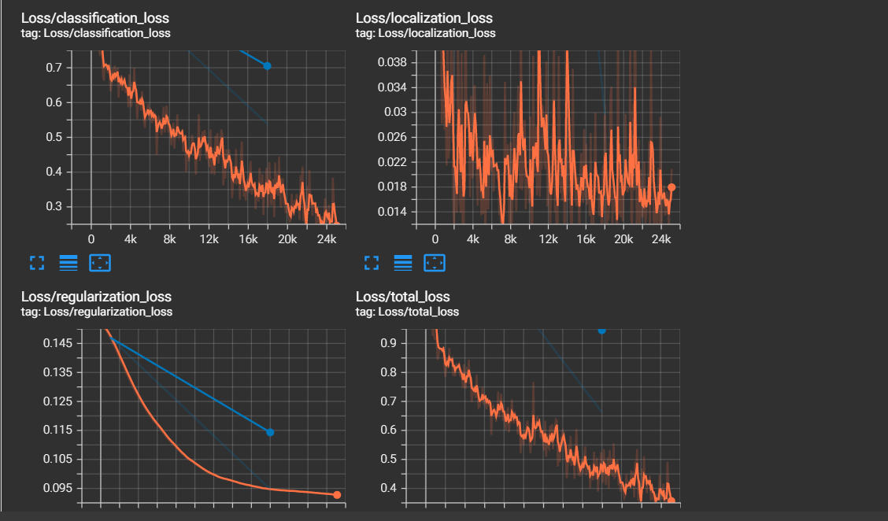

#### **SSD Object mAP**

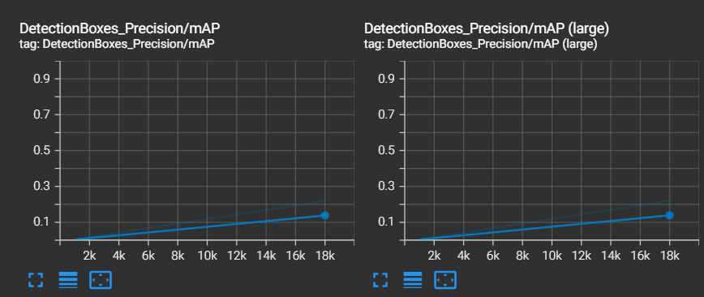

#### **SSD Object mAP Recall**

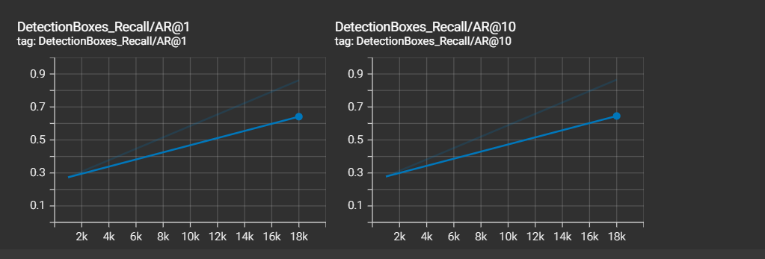

### **Faster RCNN**

Step 81300 per-step time 0.385s INFO:tensorflow:

{'Loss/BoxClassifierLoss/classification_loss': 0.00025892313, 'Loss/BoxClassifierLoss/localization_loss': 0.0,

'Loss/RPNLoss/localization_loss': 0.42648917,

'Loss/RPNLoss/objectness_loss': 0.54572624,

'Loss/regularization_loss': 0.0,

'Loss/total_loss': 0.97247434,

'learning_rate': 0.014088149}

#### **RCNN Loss Graph**

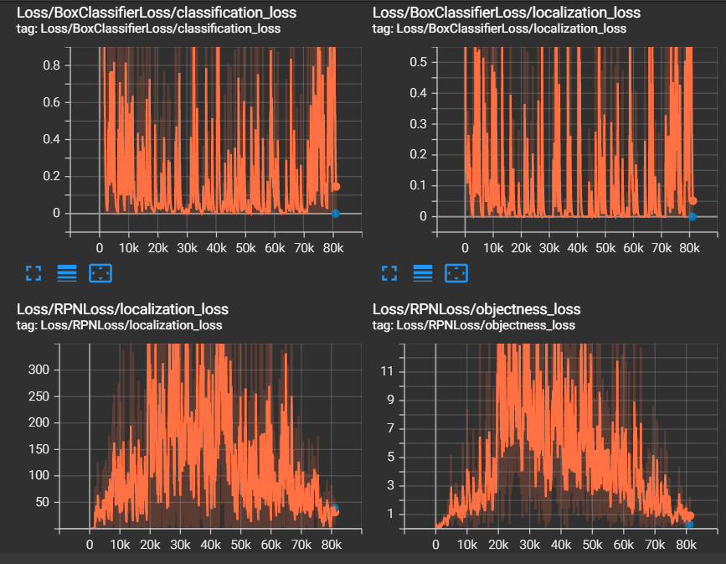

#### **RCNN Object mAP**

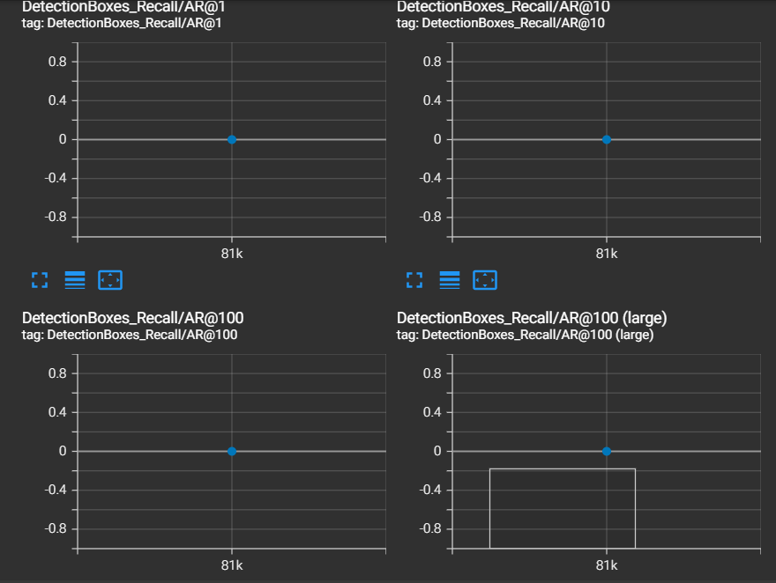

### **YOLOV5**

#### **mAP YOLOV5**

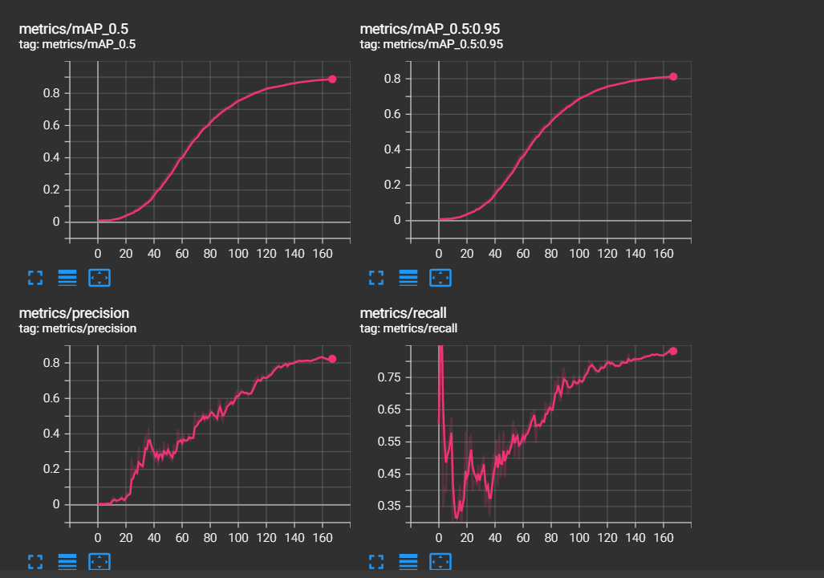

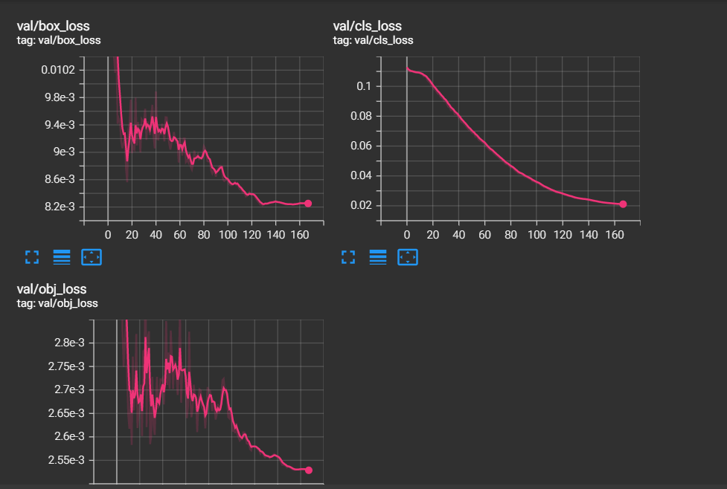

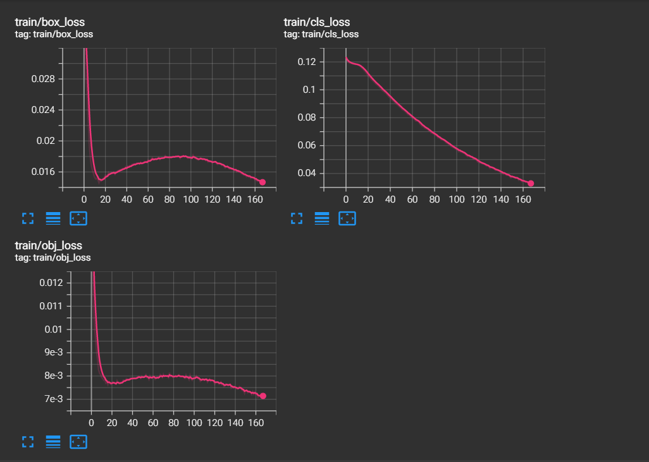

## **5.Comparison to benchmark**

As explained the model did achieve the benchmark that was laid out on the outset. There is scope for further improvement of the model. The model could be tuned for the hyper parameters. Following were the reasons for not tuning the model further:

1. The baseline performance was reached with the smallest pre-trained model (YOLOV5s)
2. Since the dataset was huge, it took huge amount of computational power to perform the experiments. The cloud GPU was exhausted. Hence better hardware must be used for hyper parameter training.

## **6.Visualizations**

Following are the train and validation set results achieved with YOLOV5:

### **F1 Curve**

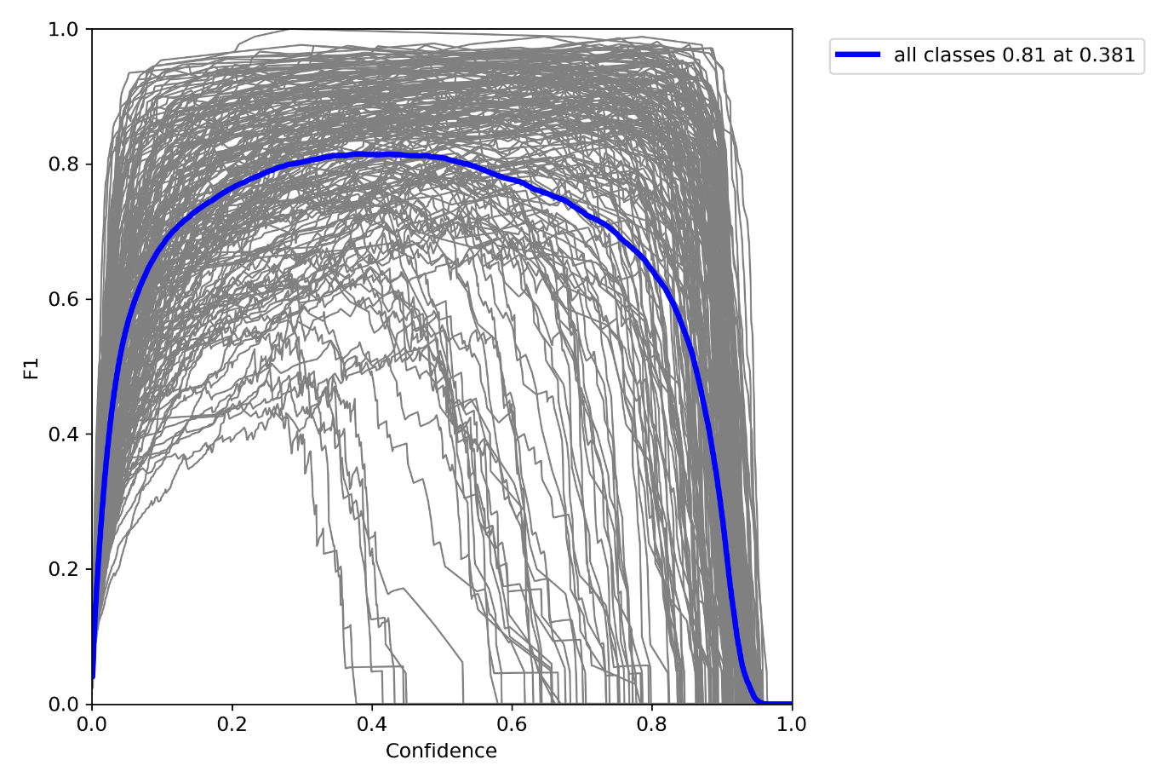

### **PR Curve**

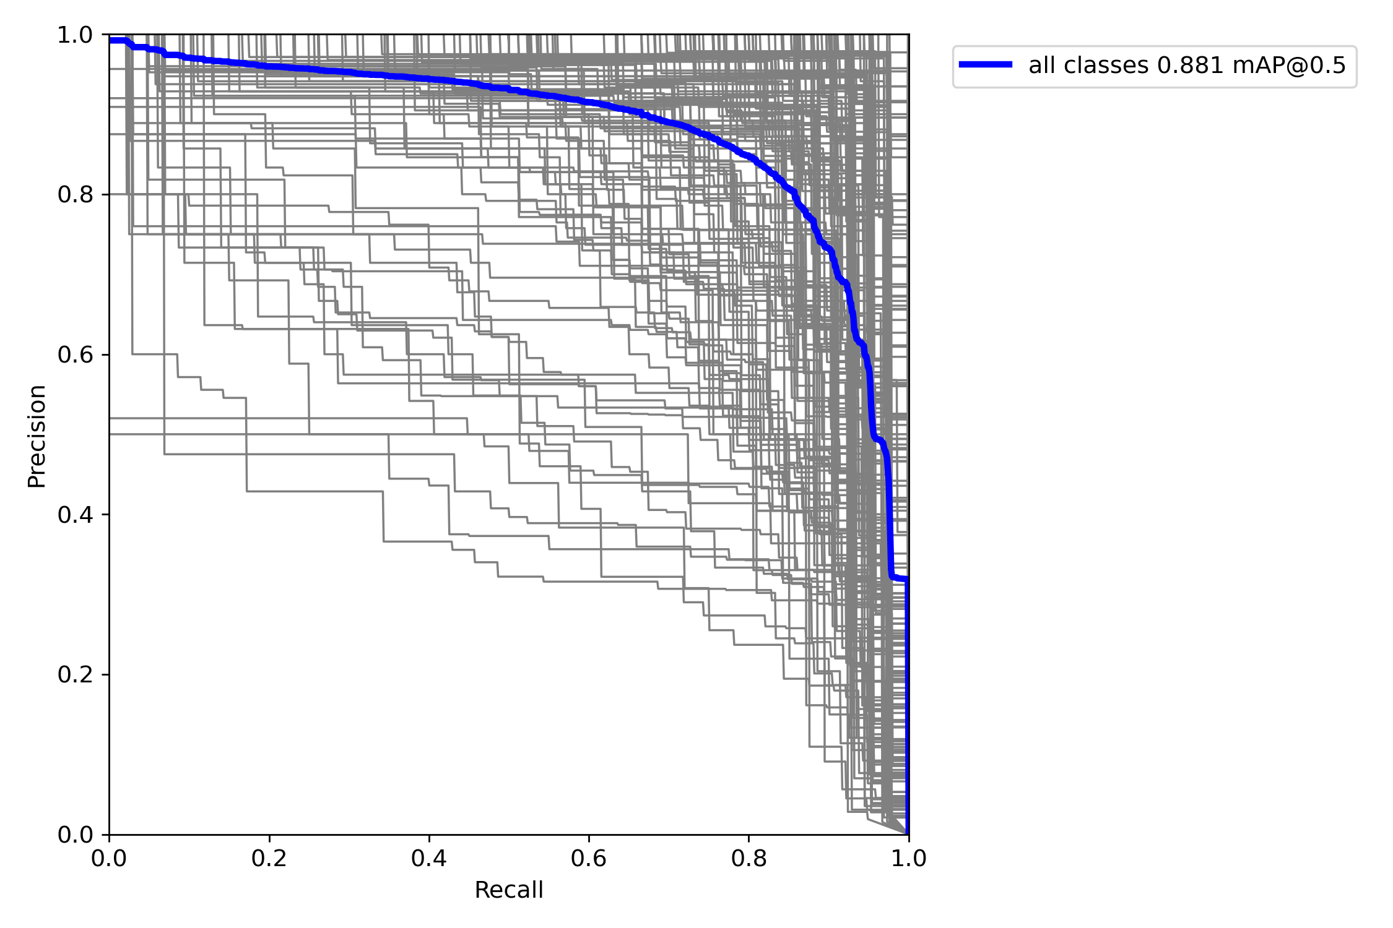

### **P Curve**

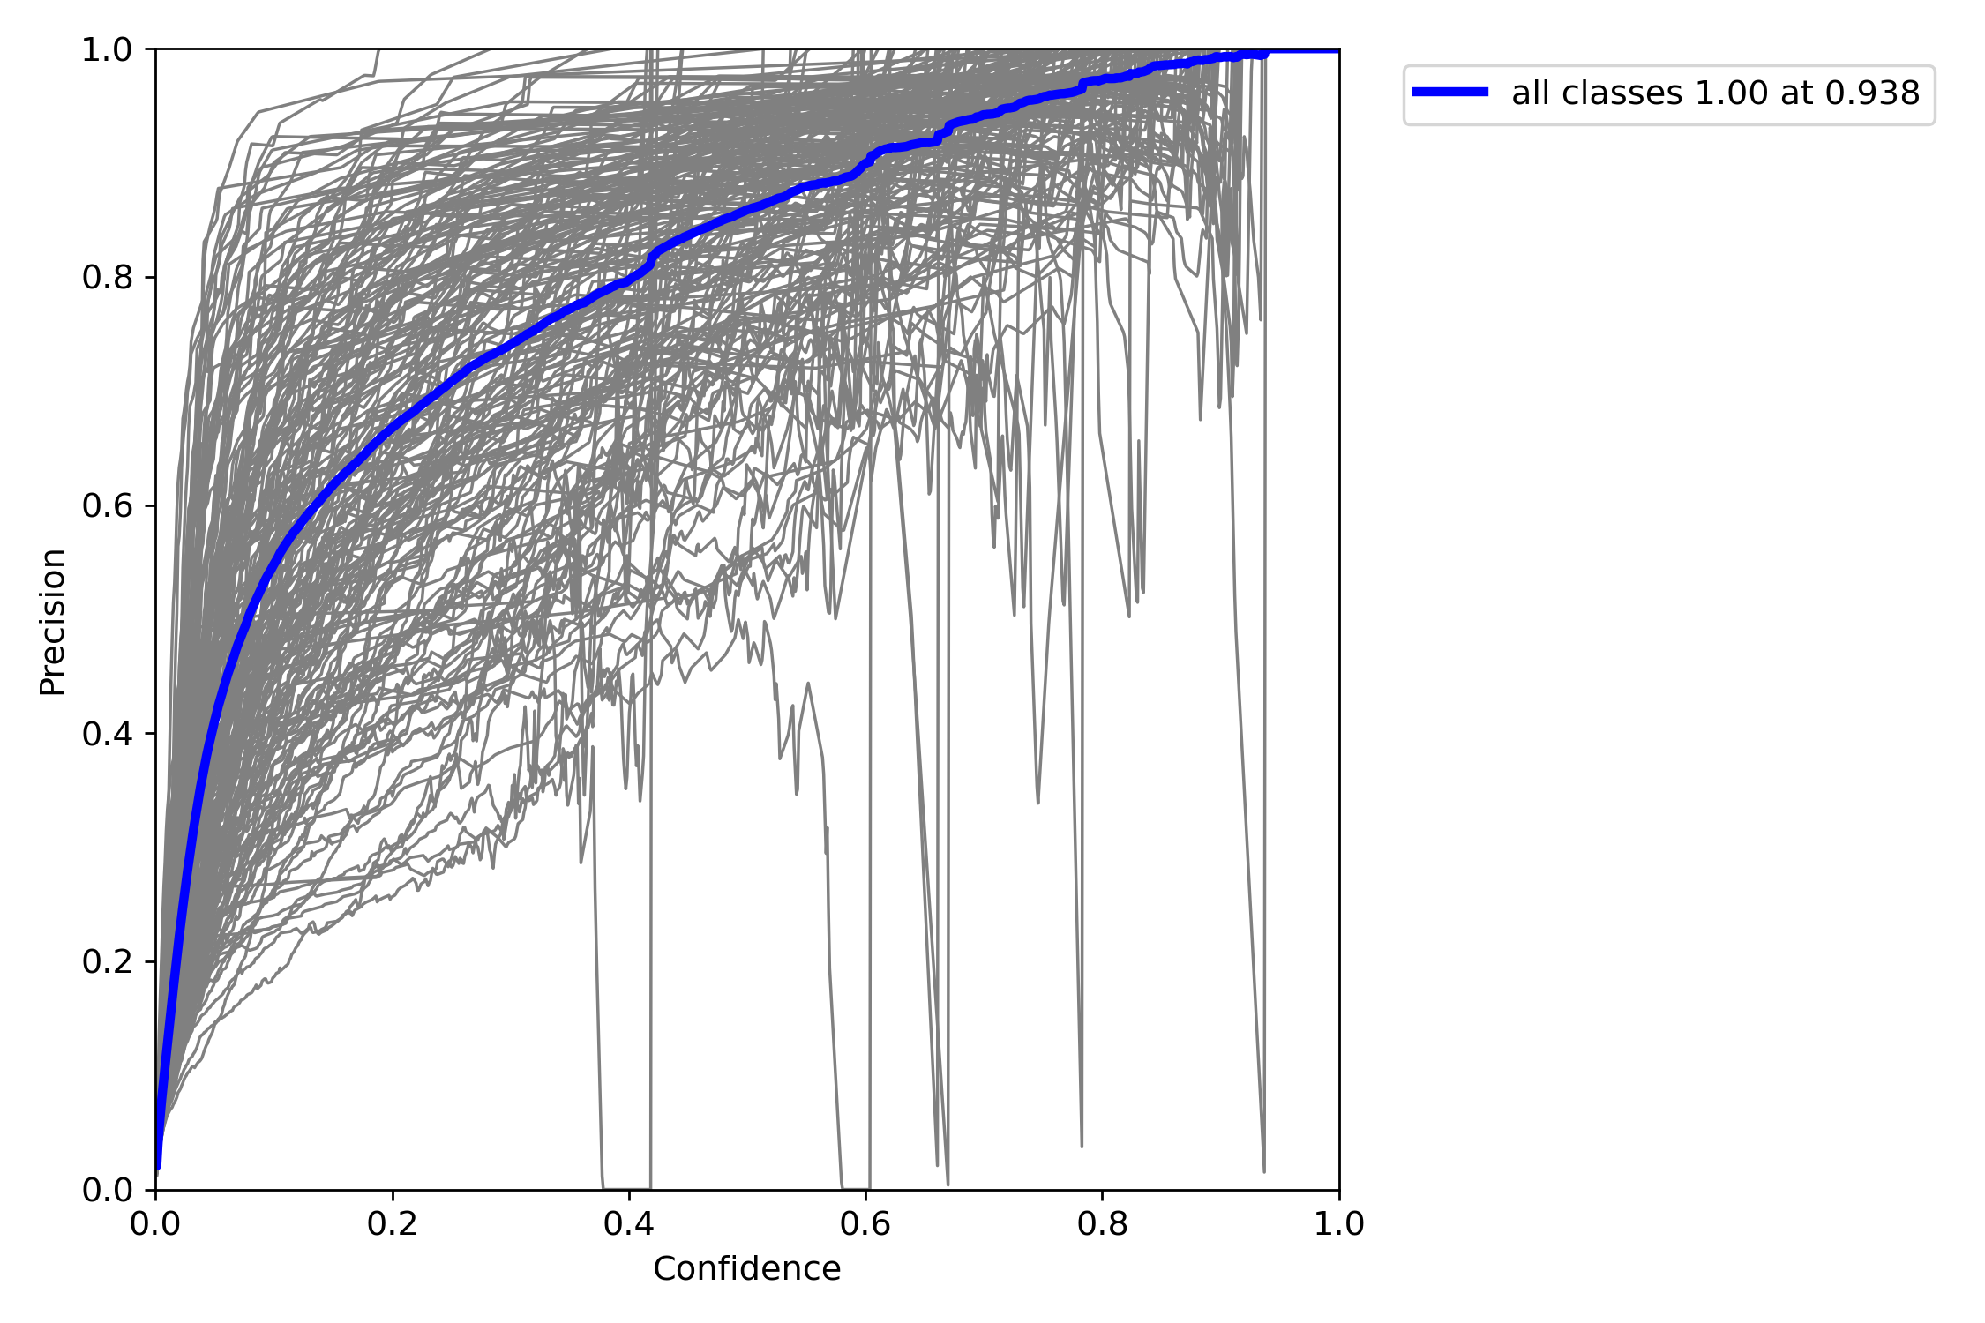

### **R Curve**

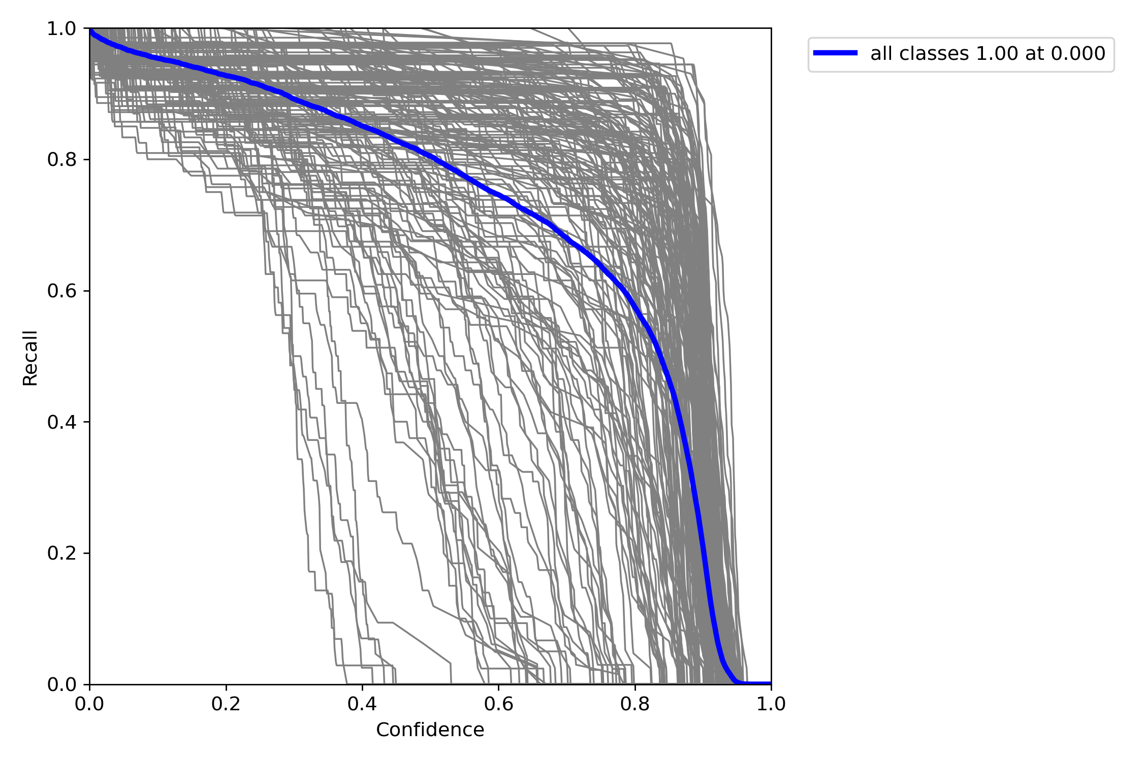

### **Confusion Matrix**

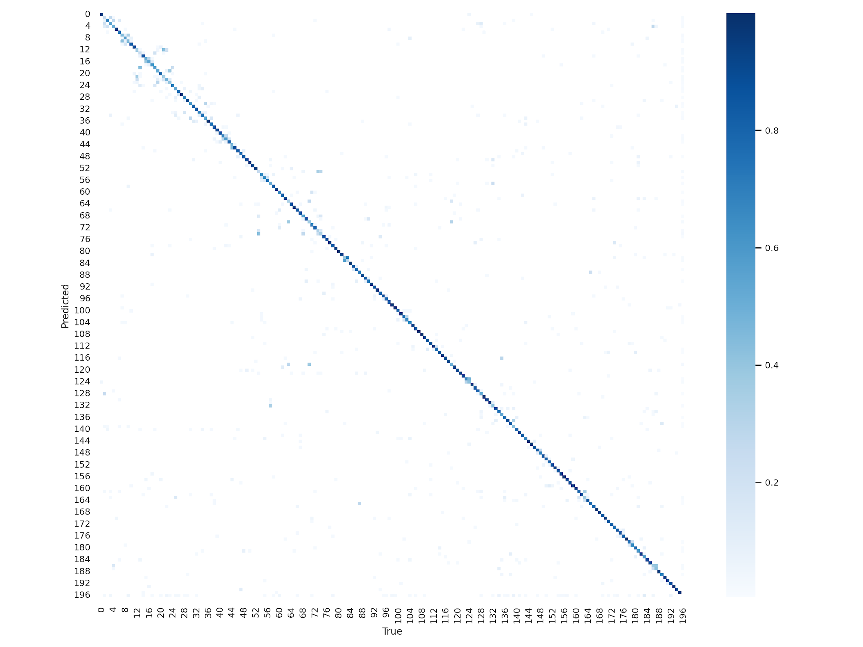

### **Example predictions**

#### **Batch 1**

##### **Labels**

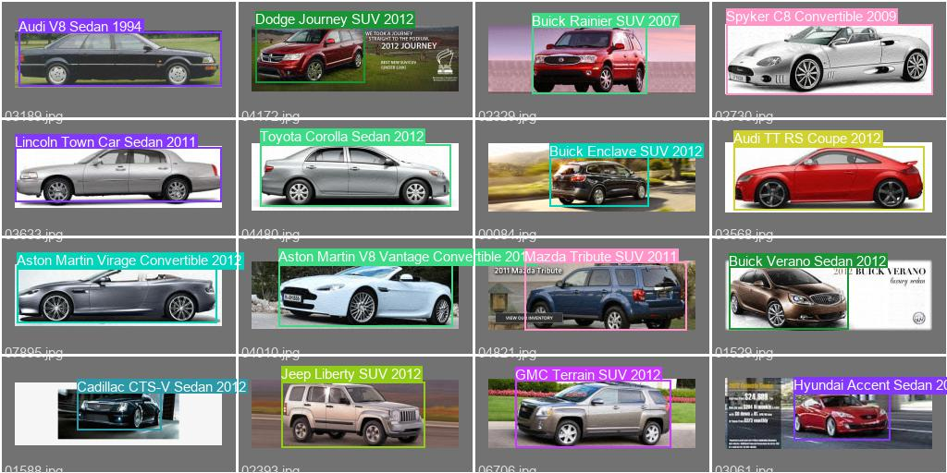

##### **Predictions**

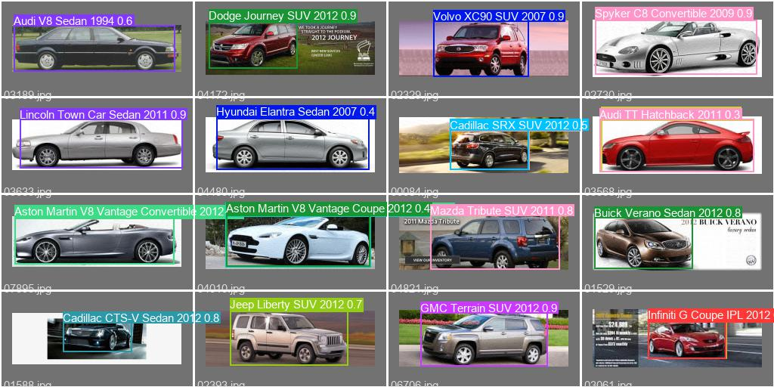

#### **Batch 2**

##### **Labels**

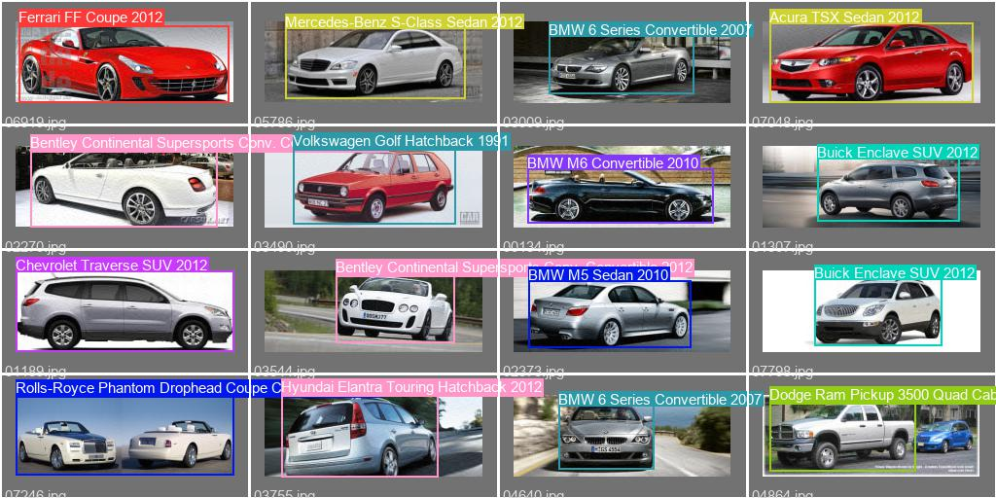

##### **Predictions**

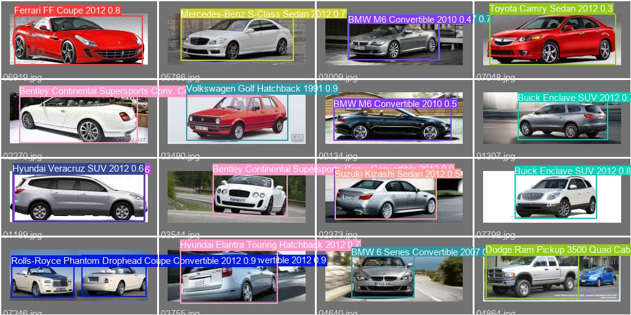

#### **Batch 3**

##### **Labels**

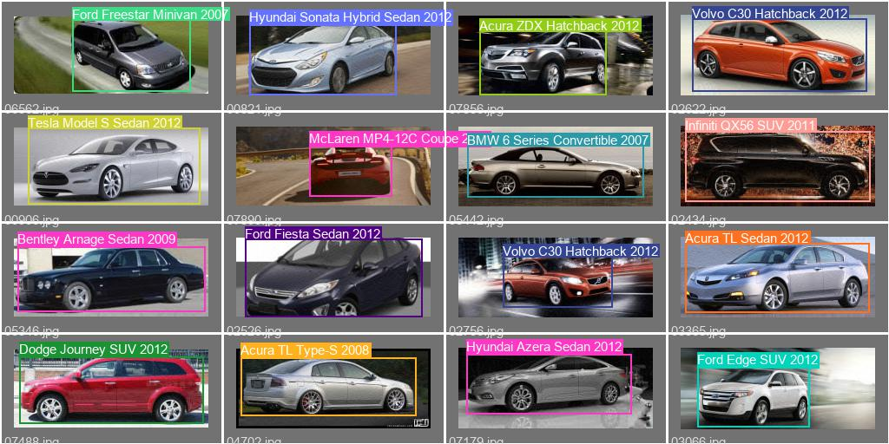

##### **Predictions**

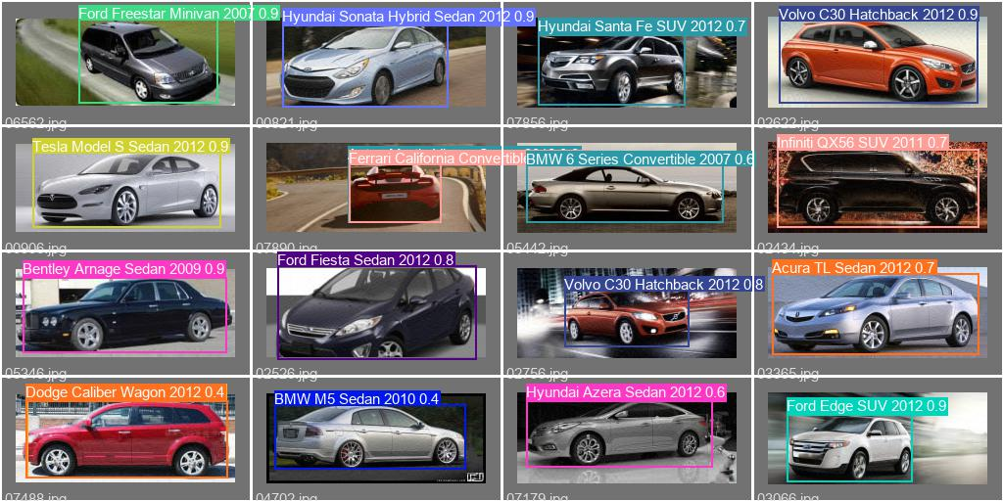

**Welcome Page**

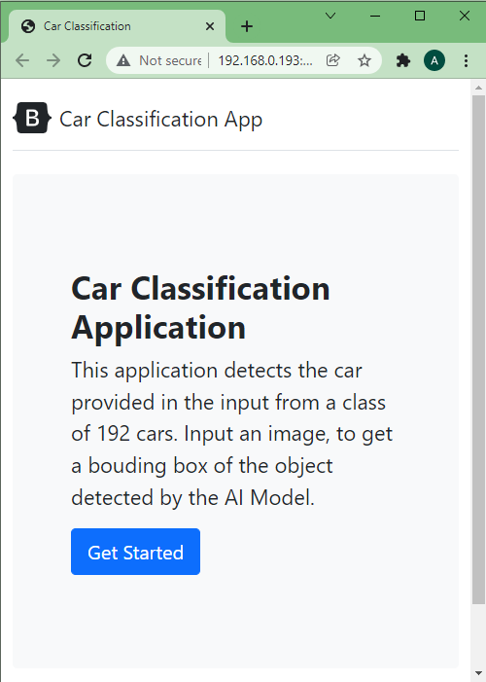

**/classify**

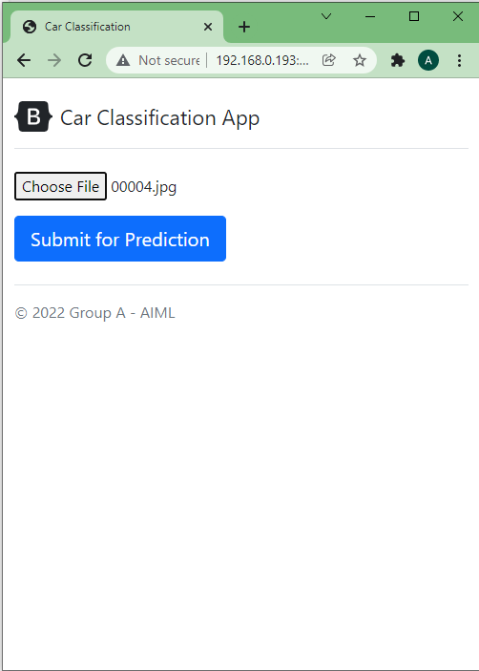

**/result**

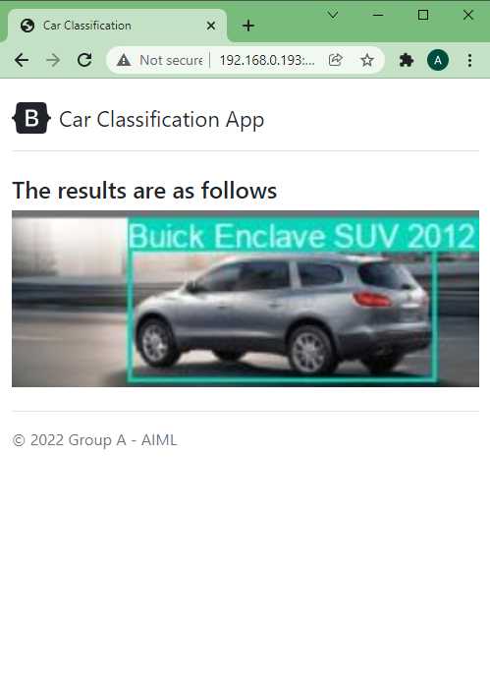

## **7.Implications**

Following two use case to explain the implication of the model on the business domain.

### **Used Car Portal**

By using the model to detect the make, year and the model of the car, whenever an user uploads the photo suggestions can be provided. This will make the process of putting a car for sale much easier. By making this easier for the user(seller), the user would recommend this to others. Also, there would be many cars to choose from for a potential car buyer. Even if the seller is not sure about the metadata, we can complete the metadata for him.

Car buyers can be shown related cars with similar make and model. This will increase the options to choose from for the buyer. This will incentivize the buyer to spend more time and look at the cars.

### **Car Garage**

By using the model, the car garage software system can automatically detect the make, model and the year of the car. This will help the car garage application to automatically fetch all the metadata for the detected make and model of the car. For example, when a car comes to the garage, the make, model and other meta data of the car is fed manually into the software. The details like wheel balancing, wheel aligner, are specific for each make and the model and year of the car.

However, with this model, that can be automated. This will lead to quicker servicing of the cars. This will also reduce the manual errors. With the manual process, the technician competency plays a huge role. However, by automating this through the model, the dependency of the technician's competency is removed.

The current solution will give 90 +/-5 level of confidence.

## **8.Limitations**

1. The accuracy of the model is around 92% . This would be fine for many use cases identified earlier. However, if the use case demands higher accuracy, then further tuning of the model is required or we can use multi-stage detection algorithm like faster RCNN.
2. One class per image would be detected. Since the input contained only one classification for each image, the training was done on single classification per each image.
3. The classifier works on the 196 models that it is trained on. There would be other types of cars, for which the model would not return a result.

## **9.Closing Reflections**

The importance of the project was in coming up with the model, by understanding the business case, the data provided, the algorithms available and the processing power for the computation.

Major learnings from the process:

1. The process and the methodology is very important to identifying the best model.
2. The processing power required to process around 16k images is non trivial.
3. Significant budget must be appropriated for quality hardware, or a GPU based cloud solution.
4. Deployment of the model is equally important to provide a better experience to the user. Hence, metrics related to real time processing like inference speed must be one of the important parameters tracked.
5. Single shot methods like YOLOV5 provides comparatively better performance compared to the other algorithms available.
6. A two-tiered approach could be used in the future. Since the images under each class was not same, there could be a two-tiered approach, where a model would classify the images which has high data, and if there is no match it is passed across to another model that detects the object among classes that has less data.

Following things would be done differently.

1. Choose an algorithm earlier in the process. Ideally before tuning the algorithms. This would essentially mean that more experimentations could be done to choose the best hyperparameter as well as the best pre-trained model for the algorithm. Though this might not provide marginal gains, however it would be able to give a further better model.